OOPS ASSIGNMENT 4
- reate a class named 'Rectangle' with two data members- length and breadth and a function to calculate the area which is 'length*breadth'. The class has three constructors which are :
  - having no parameter - values of both length and breadth are assigned zero.
  - having two numbers as parameters - the two numbers are assigned as length and breadth respectively.
  - having one number as parameter - both length and breadth are assigned that number.
Now, create objects of the 'Rectangle' class having none, one and two parameters and print their areas.

CODE:
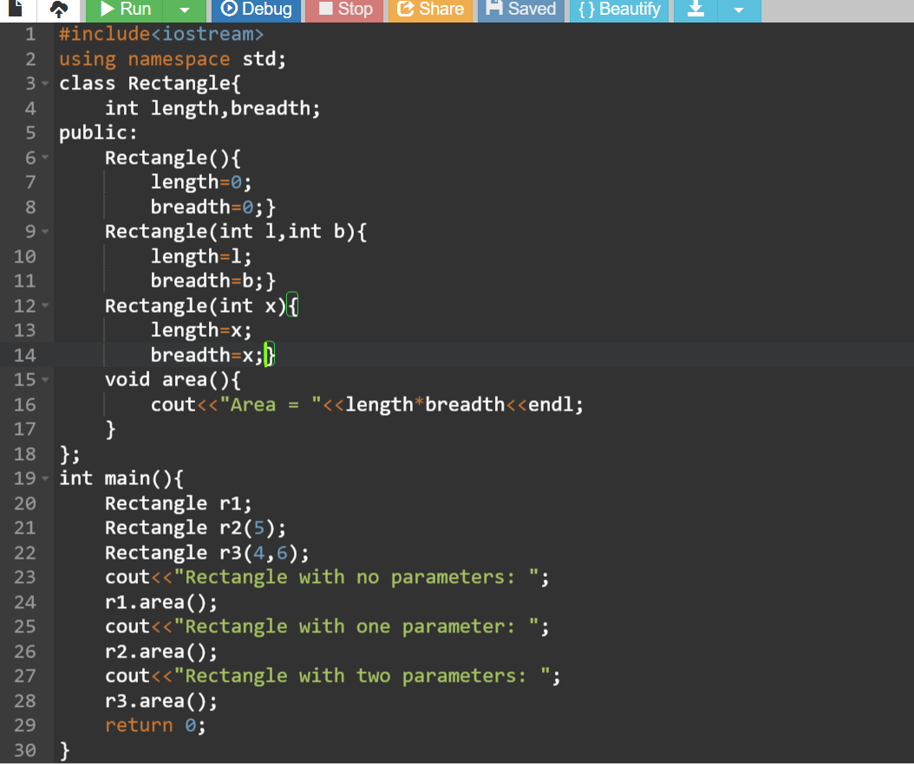

OUTPUT:
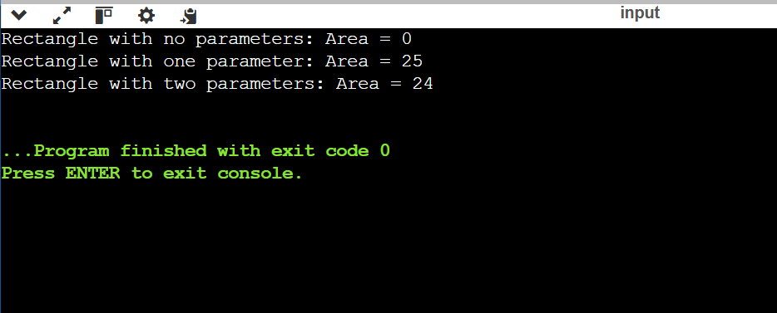

- Redefine the above program by creating an array of objects of the class Rectangle and calculate area for each object calling different constructors. Also implement constructors with default arguments and destructor in this program.

CODE:
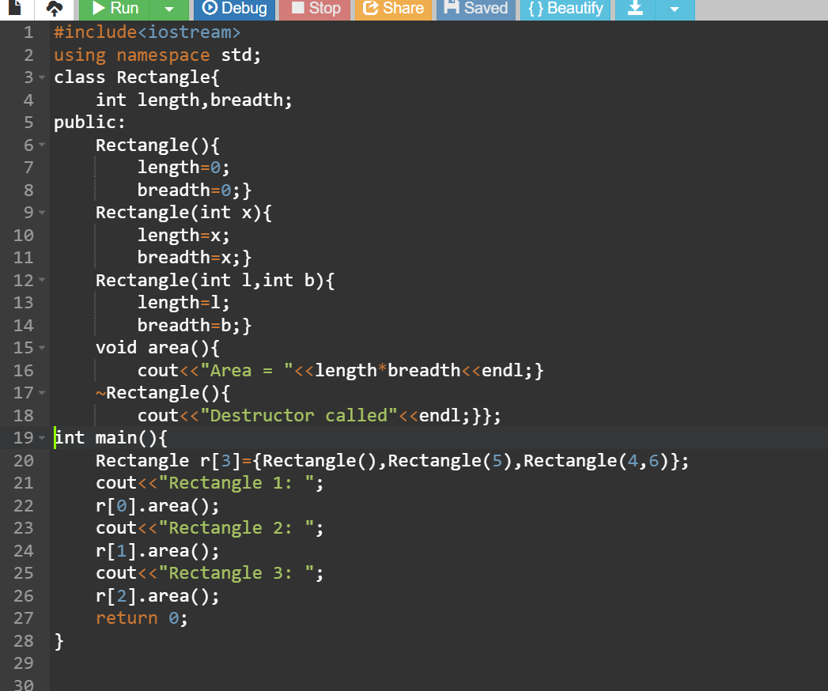

OUTPUT:
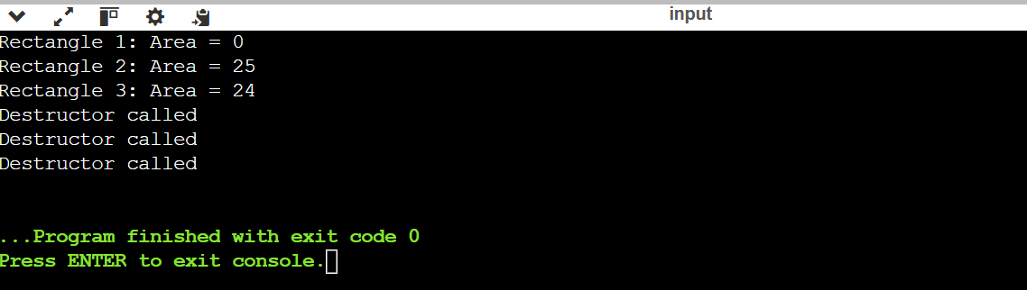

- Implement dynamic memory allocation. Use new and delete keywords.
(For integer variable, float variable, integer array, float array, class objects, Array of Objects)
CODE:

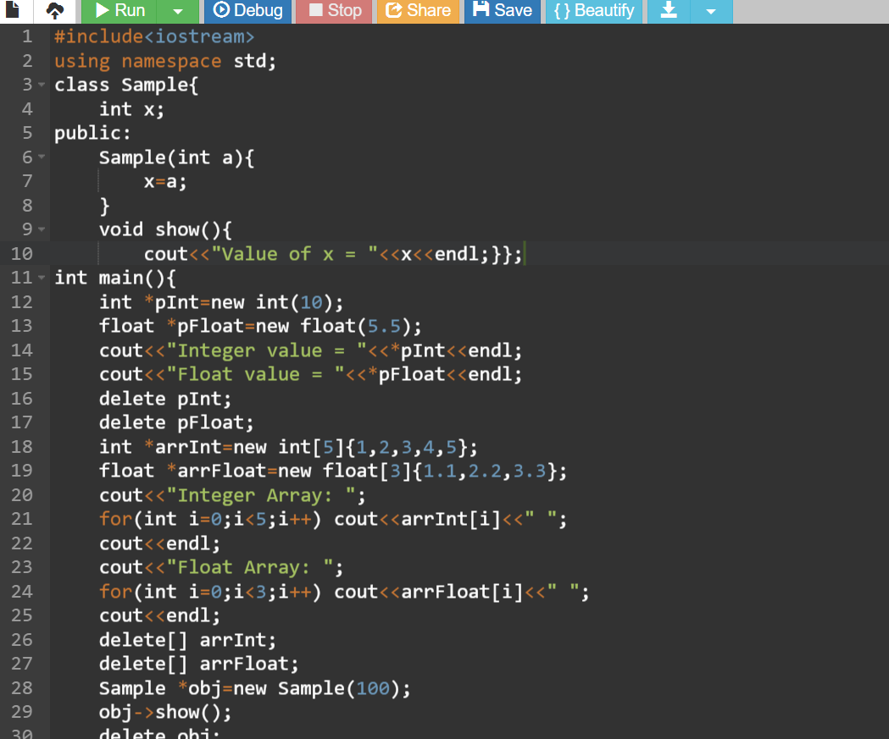
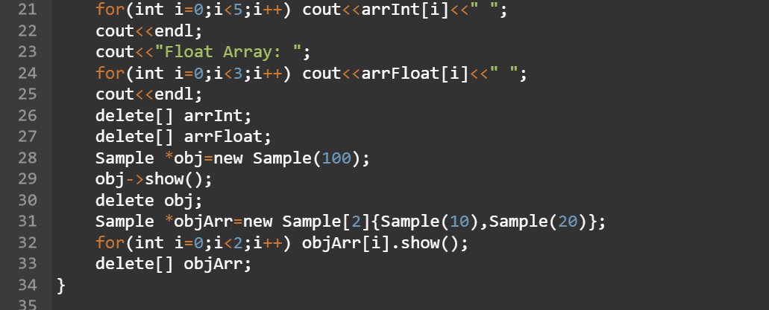

OUTPUT:
